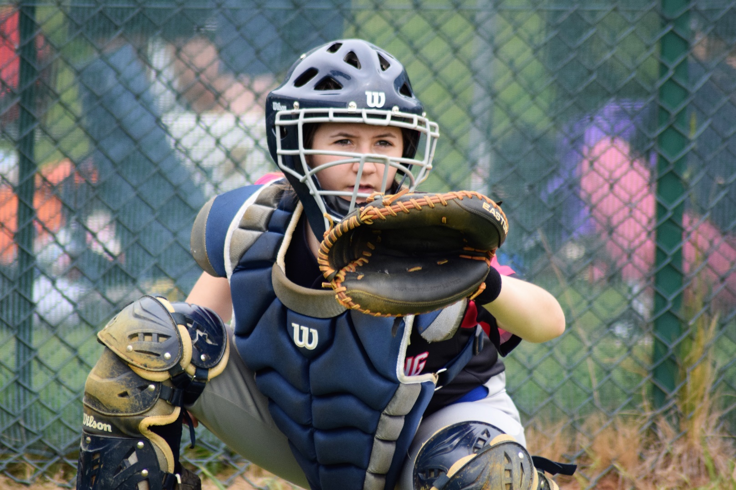

Safeguarding Policy For Trips

Equality, Diversity and Inclusion (EDI)

Equality, Diversity and Inclusion (EDI) ensures fair treatment and opportunity for all. It aims to eradicate prejudice and discrimination on the basis of an individual or group of individuals’ protected characteristics.

BaseballSoftballUK takes seriously its role in recognising and removing any barriers faced by people involved or wanting to be involved in our sports, in any capacity, to ensure the culture of our sports are improved to one that values diversity and enables the full involvement of disadvantaged groups in every aspect of our sports.

Safeguarding Policy for Trips

Travelling to play games in the UK or abroad can provide many young baseball and softball players with positive and exciting experiences that can add to their sporting and personal development. However, these types of experiences bring particular challenges and potential safeguarding issues that need to be considered and addressed -- and the key to addressing them is the preparation and planning that needs to take place before the trip.
To help you plan an overnight trip or travel abroad with a youth baseball or softball team, BSUK has a Checklist (Trips and Travel Abroad) that can be downloaded from the BSUK website that you can use to organise the trip.
When travelling abroad on trips that involve overnight stays, team organisers must ensure that the following procedures are carried out:
- Parental Permission Forms must be completed for each player (a copy must be sent to BSUK, which holds the database of permission forms). These must include emergency contact details.
- Organisers must provide BSUK with contact information and an itinerary 14 days before the team travels so that BSUK can help if an emergency arises.
- A copy of the insurance policy is provided to BSUK.
- Procedures to cover emergency situations that may arise. If overseas where to notify eg British Embassy.
- Players must be adequately insured and covered for competitive play.
- All teams must have a nominated and trained Safeguarding Officer travelling with the team, who will have overall responsibility for the trip from a safeguarding point of view.
- Each player must have his or her own bed to sleep in.
- The correct supervision ratio between adults and children must be adhered to. For domestic trips a ratio of 1:6 may be suitable, but for foreign travel a ratio of 1:4 is required.
- There should be a mix of male and female supervisors.
- Supervisors must have a valid criminal record check (DBS) prior to travelling and completed safeguarding and first aid training.
- A Risk assessment has been completed.
- Codes of Conduct are adhered to at all times.
- A debrief/report submitted to BSUK at the end of the trip.
- Immediate contact if a child/young person/adult at risk becomes ill or is injured.

NOTES
Insurance: If travelling abroad, ensure that players have adequate travel insurance that covers them for competitive play. Please visit the insurance section on the BSUK website for further details: http://baseballsoftballuk.com/insurance/travel.
Vetting: Do your homework before you travel and check what the accommodation is like. As a general rule, if you wouldn’t stay there with your own child, you shouldn’t be using it for the trip! If the accommodation is overseas, it clearly won’t be practical to visit in person before the trip, but maybe some online research (Trip Advisor) and/or local contacts can help verify that where you are staying is what you need and are expecting.

Sleeping arrangements -- If on an overnight trip, please ensure that every child has his or her own bed to sleep in. It is not acceptable for players to share a bed (at any age).
Supervision ratio – Thought should be given to what is an acceptable level of adult supervision for a trip. For a UK-based day trip, a ratio of 1:6 may be suitable, but supervision should be increased if an overnight stay or foreign travel is part of the trip, in which case 1:5 should be a minimum, and 1:4 is more suitable for foreign trips. There should be a mix of male and female supervisors.
Contact Information -- When planning any trip abroad, give contact information for BSUK Safeguarding Officers to parents so that, in the event of an emergency, BSUK is able to help.
The Checklist is a guide, and it is worth remembering that the trip organiser is ultimately responsible for the trip and all the elements that go into it.
Trip Checklists, Permission Forms and travelling team Contact Forms are available to download from the policy section of the BSUK Safeguarding website to help make planning your trip easier and safer.

Policy Last reviewed | Reviewed By (Consultant) | Approved by | Next review date
Feb 24 | Katherine Bates |  | Feb 26

