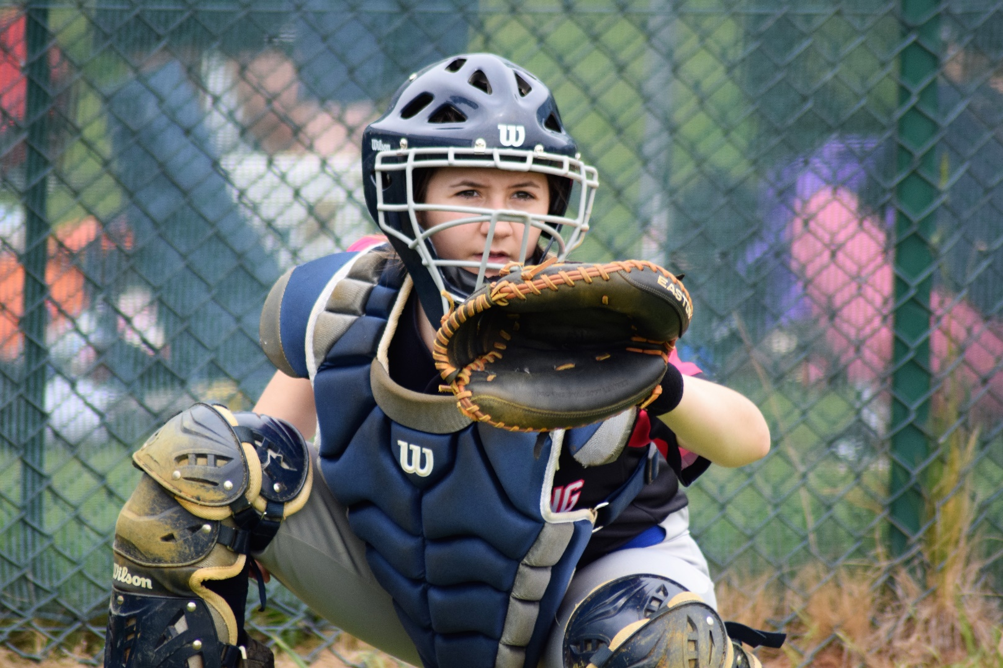

Safeguarding Complaints Procedure for Baseball and Softball

Diversity, Equality and Inclusion

Diversity, Equality and Inclusion (DEI&I) ensures fair treatment and opportunity for all. It aims to eradicate prejudice and discrimination on the basis of an individual or group of individuals’ protected characteristics.

BaseballSoftballUK takes seriously its role in recognising and removing any barriers faced by people involved or wanting to be involved in our sports, in any capacity, to ensure the culture of our sports are improved to one that values diversity and enables the full involvement of disadvantaged groups in every aspect of our sports.

Safeguarding Complaints Procedure for Baseball and Softball

Introduction
The British Softball Federation (BSF) and BaseballSoftballUK are committed to promoting the welfare of all involved in baseball and softball, and we aim to provide a process that will make it simple and straightforward for people to raise any concerns they may have.
The procedure set out below explains how to deal with a complaint resulting from a safeguarding concern related to someone under the age of 18 or an adult at risk (vulnerable adult).
The broad definition of an adult at risk (vulnerable adult) is ‘a person who is 18 years of age or older, and who is or may be in need of community care services by reason of mental or other disability, age or illness and who is or may be unable to take care of themselves, or unable to protect themselves against significant harm or serious exploitation’.
The procedure below is mandatory for all BSF and BaseballSoftballUK officials, staff and members.
Responsibility for ensuring that the procedure is followed rests ultimately with the Executive Boards of the BSF and BaseballSoftballUK. Clubs and leagues are also responsible for ensuring that concerns raised in relation to their members are handled in accordance with this procedure. Failure to adhere to the procedure is a disciplinary offence.
It is essential that young people and adult at risk are able to make a complaint. Everyone within the sports should be familiar with this procedure, and should make it as easy to use as possible. The rights of the young person or adult at risk involved should be protected and their safety ensured throughout the process. Just as importantly, all parents and guardians of young people involved in the sports need to be assured that any concerns they raise or complaints they make regarding the welfare of a young person will be dealt with in the appropriate way. Those with caring responsibilities for adults at risk require similar assurance.
The Safeguarding Complaints Procedure must be followed
- when a concern or complaint is received from any participant, official or staff member, or from someone responsible for the welfare of a participant (such as a parent, guardian or carer); and
- the concern or complaint involves someone under the age of 18 or an adult at risk, and is deemed to be a safeguarding matter by the relevant Club Safeguarding Officer.
Where there is any doubt about whether the concern or complaint is a safeguarding issue, or where no suitably trained or qualified Club Safeguarding Officer is available to determine an appropriate course of action, advice must be sought from the BaseballSoftballUK Safeguarding Officer or another appropriate source. (i.e Police, Children’s social care, Adult social care)
If a concern/complaint is considered to relate to abuse or neglect, it should be referred at the earliest opportunity to a statutory agency or to the BaseballSoftballUK Safeguarding Officer, who will refer the matter to a statutory agency if appropriate.

Safeguarding Complaints Procedure

Note: The term “Club Safeguarding Officer” in this document is used generically to identify the official responsible at a local level within a club, league, team or other structure who is trained and has responsibility for safeguarding issues. Where a complaint or concern is raised in a different context (e.g. a national team or Academy event), the staff member or official trained and nominated with responsibility for safeguarding issues should take the role set out below for the Club Safeguarding Officer. Where no Club Safeguarding Officer or equivalent is available for any reason, the BaseballSoftballUK Safeguarding Officer should take the role set out below for the Club Safeguarding Officer.

Complaints or concerns are considered on three levels:

Level 1
- Resolve locally in an informal manner.
- Timescale – IMMEDIATE
As an adult member of the BSF or BaseballSoftballUK, when a child, parent, guardian, vulnerable adult or carer makes a complaint or draws your attention to a concern, you must first decide whether it is appropriate for you to resolve it. For example, if it is child and you are in a suitable position to address the concern, you should do so. However, you should consult your Club Safeguarding Officer before taking any such action.
As is the case with any complaint, confidentiality must be maintained and information should be shared on a ‘need to know’ basis -- i.e. with the young person's parents, the Club Safeguarding Officer and the coach. This close circle of people may be extended but only if the situation calls for it. For example, the Team Manager may need to be informed if the complaint has originated from a team training session.
If you are unable to address the concern immediately yourself to the satisfaction of the complainant, you must refer it to your Club Safeguarding Officer to be handled at Level 2.

Level 2
- Resolved by Club Safeguarding Officer.
- Timescale – 7 DAYS.
The Club Safeguarding Officer will deal with the complaint or concern in much the same way as at Level 1 but on a more official level. Their primary concern will be to satisfy the child, parent, guardian, adult at risk or carer that their complaint has been resolved.
The complaint could be referred to them from Level 1 or the complainant may have come to them directly. The Club Safeguarding Officer will then consider whether he or she is able to address the concern. It is anticipated that the Club Safeguarding Officer will be able to resolve minor issues through the club's own complaints procedures.
The BaseballSoftballUK Safeguarding Officer may be consulted before any action is taken. Regardless of whether support from the BaseballSoftballUK Safeguarding Officer is sought, notice of the original complaint, any action taken and the outcome must be reported to them afterwards. The Club Safeguarding Officer should only deal with general welfare matters; matters relating to abuse or neglect must immediately be referred to the appropriate statutory agency and the BaseballSoftballUK Safeguarding Officer.
The Club Safeguarding Officer must complete the following duties when dealing with a complaint:
- Record the complaint made.
- Record the action taken to resolve the complaint.
- Maintain confidentiality whilst dealing with the complaint, including secure storage of related documentation (if storage is electronic it must be password protected, all hard copies should be held in a locked fireproof filing cabinet).
If the Club Safeguarding Officer is unable to address the concern within seven days to the satisfaction of the complainant, they must refer it to the BaseballSoftballUK Safeguarding Officer to be handled at Level 3.

Level 3
- Resolved by the BaseballSoftballUK Safeguarding Officer.
- Timescale – 3 DAYS.
The BaseballSoftballUK Safeguarding Officer has the right to be involved in any safeguarding matter that s/he or any of the BSF or BaseballSoftballUK deems requires their involvement.
This involvement would primarily come from:
- A complainant remaining unsatisfied that the matter has been resolved adequately at Level 1 or 2.
- The matter being referred to the BaseballSoftballUK Safeguarding Officer by the Club Safeguarding Officer at Level 1 or Level 2.
- At any stage of the complaints procedure a participant, young person, parent, guardian, vulnerable adult or carer contacting the BaseballSoftballUK Safeguarding Officer directly.
The BaseballSoftballUK Safeguarding Officer will liaise with the Club Safeguarding Officer to ensure the complaint is being dealt with correctly. The Club Safeguarding Officer will be held accountable for the club following the guidance of the BaseballSoftballUK Safeguarding Officer. It is the BaseballSoftballUK Safeguarding Officer's decision alone as to how much s/he is involved in the issue.
Throughout the BaseballSoftballUK Safeguarding Officer's involvement, s/he will continue to reassess the situation and may decide to:
- Refer the complaint to a statutory agency.
- Request that the BaseballSoftballUK Safeguarding Officer or an independent investigator complete a fact-finding assessment surrounding the complaint.
- Appoint suitable panel to provide Safeguarding Case Management Support.
- Make a formal complaint in accordance with the relevant BSF/BaseballSoftballUK rules.
- Make formal recommendations to the BSF or BaseballSoftballUK in respect of required changes to policy and practice, appropriate disciplinary investigation or any other matter.
- Take further action as necessary to ensure that the welfare of the young person or vulnerable adult concerned remains paramount.
All clubs must be aware that if guidance from the BaseballSoftballUK Safeguarding Officer is not taken into account when dealing with the matter, this could result in disciplinary action on the basis that the club has failed to follow the Safeguarding Policy.
The BaseballSoftballUK Safeguarding Officer should decide upon their level of involvement in the matter and inform all of the parties involved of their position within three days. The BaseballSoftballUK Safeguarding Officer will aim to have resolved the matter or decided on any further action needed within three months of the original referral.
Where this is not possible -- i.e. after the involvement of a statutory agency -- the BaseballSoftballUK Safeguarding Officer will keep the child or adult at risk and their parent, guardian or carer informed of the progress of their complaint.

Appeal
The BaseballSoftballUK Safeguarding Officer's decision on whether to close the complainant's file and/or recommend an alternative action is final.
Where the recommendations of the BaseballSoftballUK Safeguarding Officer result in disciplinary action, the relevant disciplinary rules will be followed, including those relating to appeal against any resulting sanction.

Contact

The BaseballSoftballUK safeguarding Officer can be contacted at the BaseballSoftballUK office on 020 7453 7055 or by emailing welfare@bsuk.com.

Policy Last reviewed | Reviewed By (Consultant) | Approved by | Next review date
Feb 22 | Herra Sports | Governance Committee | Feb 24

