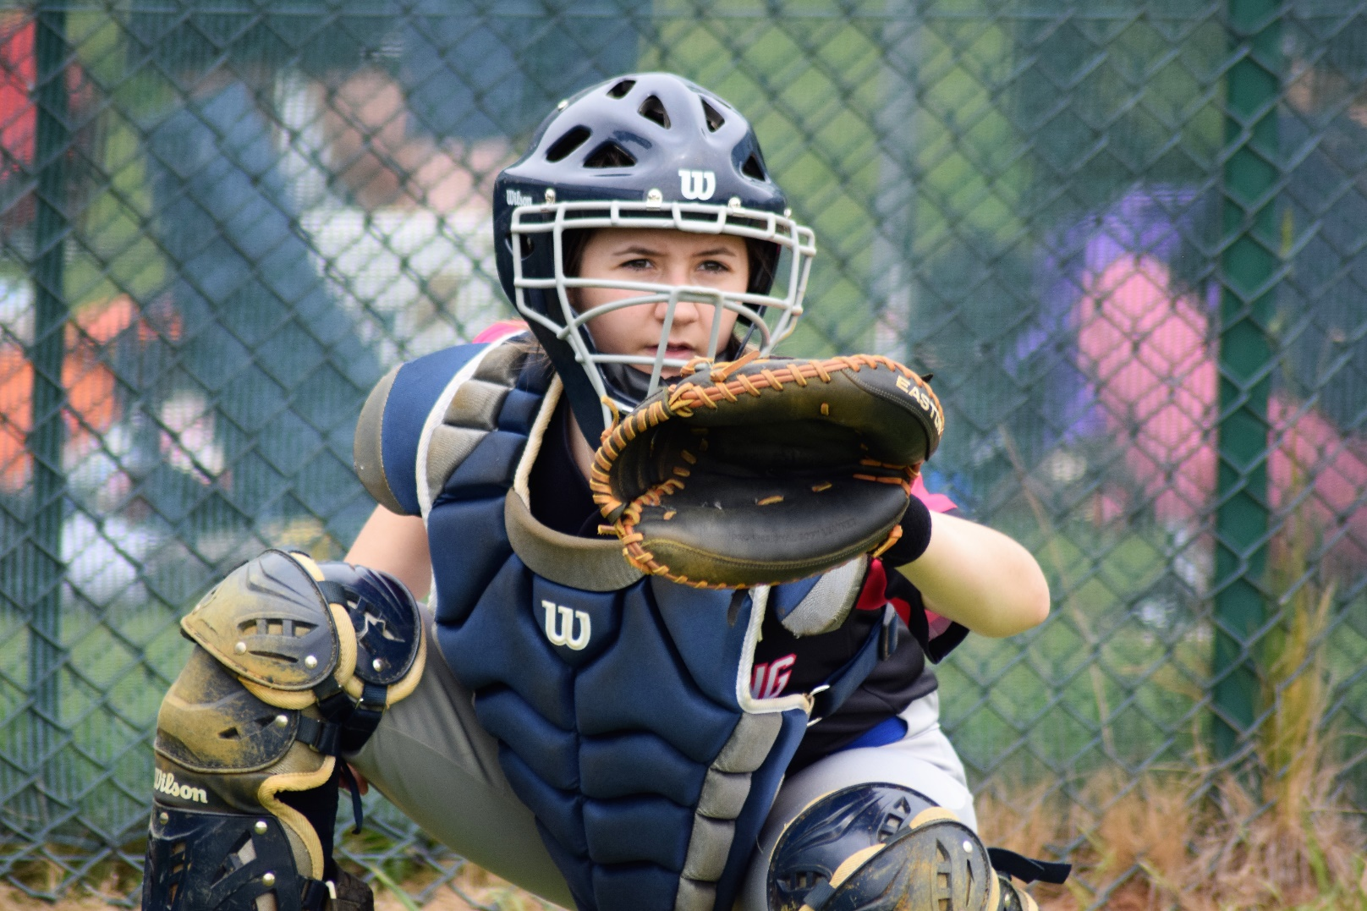

Policy and Procedures for Photography and Recorded Images

Equality, Diversity and Inclusion (EDI) Policy

Equality, Diversity and Inclusion (EDI) ensures fair treatment and opportunity for all. It aims to eradicate prejudice and discrimination on the basis of an individual or group of individuals’ protected characteristics.

BaseballSoftballUK takes seriously its role in recognising and removing any barriers faced by people involved or wanting to be involved in our sports, in any capacity, to ensure the culture of our sports are improved to one that values diversity and enables the full involvement of disadvantaged groups in every aspect of our sports.

USE OF PHOTOGRAPHIC AND VIDEO* IMAGES OF CHILDREN / YOUNG PEOPLE UNDER THE AGE OF 18

There is great benefit in creating and using positive images of young people playing baseball and softball. However, some people have used sporting events as an opportunity to take inappropriate images of young sportspeople or to use such pictures in appropriate ways.

*This includes images or recordings taken on mobile phones/tablets etc.

POLICY STATEMENT

BaseballSoftballUK/BSF and GB National Teams are committed to providing a safe environment for children/young people under the age of 18 to participate in sport. Essential to this commitment is the need to ensure that all necessary steps are taken to protect children/young people from inappropriate use of photographic or video images that might be taken of them.

Photographs and video increase the risk of identifying, contacting or grooming children and young people, particularly when accompanied by personal information.

There may also be legal restrictions that prevent a child’s identity from being published (e.g. the child is in Local Authority care or has been placed in an adoptive family), and if someone was able to identify and trace such a child. In addition, the content of photographs or video can itself be inappropriate or adapted for inappropriate use.

BaseballSoftballUK will implement the policy set out below with regard to any baseball or softball activity organised for children and young people.

Key principles

- The interests and welfare of children taking part in our sports are always paramount.
- Children and parents have a right to decide whether to give permission for the child’s image to be taken and how these images may be used. Written consent for images to be taken and used must be obtained before any photographs are taken or video footage is shot.

Consent is only meaningful when BaseballSoftballUK ensures that the child and their parents understand the nature of the potential risks associated with the intended type, use and distribution of images.

- All photographs and video images should reflect a positive impression of the sport and the participants, must feature appropriate sports kit (including recommended safety wear) and be taken in a way that reduces the opportunities for their misinterpretation or abuse.
- All photography equipment will have the audible ‘click’ sound turned on.
- Images should only be taken by authorised persons as agreed in the protocol for a particular event and some form of identification should be obtained when people are registering specifically as photographers or videographers. Such people should then be identifiable at the event, e.g. by wearing a high-visibility jacket.
- In the case of images used on websites, particular care must be taken to ensure that no identifying details about the child are provided.

Publishing images

Consent forms (see below) will be used to ask for permission from young players and their parents for images of those players to be taken and used. If a player is named, we will avoid using their photograph in such a way that the photo can be connected with the named player. If a photograph is used, we will avoid naming the player directly – for example, in a caption. We will never publish personal details (email or postal address,
telephone numbers etc) of a child or young person. Where we pass images to an approved partner for publication, we will require that they follow these guidelines in their use.
We will only authorise the use of images showing players in suitable team uniforms or on-field clothing -- for example, jerseys, baseball pants or shorts -- and suitable off-field clothing.

Images of young elite athletes

Elite-level baseball and softball events are increasingly likely to take place in a public arena. Event organisers and BaseballSoftballUK/GB National Teams will quite reasonably seek publicity to positively promote our sports, and young elite athletes receiving endorsements or sponsorship may well welcome positive media coverage on a local, regional or national level. BaseballSoftballUK/GB National Teams retains a duty of care to these athletes and a responsibility to safeguard them. In respect of some young elite athletes, however, aspects of the general guidance around the use of images detailed above (for example avoiding the inclusion of names alongside photographs) are not always practical or desirable.
Even in these circumstances, however, it is important that other aspects of this guidance (for example about the nature, content and use of images, and about ensuring that photography sessions are supervised) are considered and applied. It is important for the athletes, their parents and media representatives to be clear about appropriate arrangements and ground rules for interviews, filming and photo sessions. Young elite athletes and their parents will be supported by BaseballSoftballUK/GB national Teams in managing these and a range of other issues (including safeguarding concerns) that may arise as a result of their sporting success and increased public profile.

Use of photographic or filming equipment at BaseballSoftballUK/BSF/GB National Teams events and sessions
These include, but are not limited to, Academy, HPA, Little League, GB practices and games and Indoor softball.
BaseballSoftballUK/BSF/GB National Teams will:

- Inform players and parents when official photographers and/or videographers will be in attendance at an event or session and that photos may be taken for reporting or promotional purposes.
- Assume it has consent from players/parents for photographs or video to be taken at BSUK events, unless it is informed otherwise (before an event). Any player not giving permission (for inclusion in photographs or video) would not be included in any photos or video film produced for reporting or promotional purposes and displayed publicly.
- Not use images of any player/parent opting out of giving permission, as long as BSUK is informed of the decision prior to the start of the event/session.
- May require parents, spectators and authorised photographers or videographers, including professional media representatives, to register at certain events if they wish to use photographic or video equipment, including mobile phones with photographic technology.
- Not approve or allow unsupervised access to players or one-on-one photo or video sessions at events by any photographers or videographers.

- Not allow any photo or video images to be taken in the changing areas -- including by players.
- Not allow photo or video sessions outside the event or at a player’s home.
- Act on all concerns of players or parents regarding the inappropriate use of photographic or video equipment or images.
- Notify children / young people and their parents when video equipment is to be used as a coaching aid or for promotional purposes.
- Ensure that any photographic or video images taken and used are stored safely.

The following message will be used in communications to inform players/parents of photographic policy:

BSUK/BSF/GB National Teams may take photographs or video at events. Images and footage may be used for reporting and promotional purposes, and this may include use in printed documents or media for editorial coverage or advertising including use on the internet. Participants who do not wish their images to be used in such ways must inform the event organisers prior to the event.

Farnham Park
BSUK operates Farnham Park, and it is written into the terms and conditions that:

“BSUK may take photographs or video at events. Images and footage will be used for promotional purposes, and this may include use in printed documents or media for editorial coverage or advertising and use on the internet. Participants who do not wish their images to be used in such ways must inform the event organisers prior to the event. It is the event organisers responsibility to notify participants of this and to inform BSUK of anyone wishing that their image not be used. If you want to take your own photographs or engage someone else to do so on your behalf, you are responsible for getting permission from your participants.”

Players or parents can choose not to allow their images to be used by emailing farnhambookings@bsuk.com.

BSUK will ensure that images of such players will not be used in any photo or video recording at the event.

Photographs and video footage given to BSUK/GB National Teams

From time-to-time photos and videos of events are shared with BSUK/ GB National Teams. BSUK/GB National Teams will use the shared photos in the same way as if they had taken these images themselves (for promotion and marketing purposes etc). BSUK/GB National Teams accepts such photos and video on the understanding that any necessary permissions have been agreed and that no copyright issues are involved.

Photography or Videography Event Registration Form
BaseballSoftballUK is committed to providing a safe environment for children and young people under the age of 18 to participate in sport. Essential to this commitment is to ensure that all necessary steps are taken to protect children and young people from the inappropriate use of photographic or video images.

Name______________________________________________________

Address____________________________________________________
___________________________________________________________
Postcode____________________________________________________
Phone Numbers – Home _______________________________________
Work ________________________________________
Mobile________________________________________

Event Date(s) ______________________________________________________
(Please include start and end dates)
Event, Session or Programme Description_________________________________
_______________________________________________________________

I wish to take photographs or record video images during the course of the above session, event or programme. I agree to abide by the guidelines laid down by BaseballSoftballUK and confirm that the photographs or video images will only be used in an appropriate manner.
Please describe below how photographs or video images will be used:

I acknowledge that if it is deemed that any photographs or video images are used inappropriately, this may result in me being unable to use photographic or video equipment at BaseballSoftballUK events in the future.

Signed:

Print Name:

Date:
Photography and Video Images Permission Form
BaseballSoftballUK recognises the need to ensure the welfare and safety of all young people in sport. In accordance with our Joint Safeguarding Policy and Procedures we will not permit photographs, video or other images of children or young people to be taken without the consent of the parents or guardians and the children or young people concerned.

BaseballSoftballUK follows the Child Protection in Sport Unit's (CPSU) guidance for the use of photographs, a copy of which is available on the BaseballSoftballUK website or from the BSUK Safeguarding Officer at:
BASEBALLSOFTBALLUK
Home Plate, Farnham Park Baseball & Softball Complex
Farnham Royal SL2 3BP
Tel: 020 7453 7055

Event Date_____________________________________________________________
(Please include start and end dates)
Event, Session or Programme Description____________________________________
___________________________________________________________________
______________________________________________________________________
___________________________________________________________________

I (parent or guardian) consent to BaseballSoftballUK photographing or videoing my child’s involvement in the (insert event/session/programme) for the period of time shown on this form for the purposes of publicising and promoting the club or sport, or as a coaching aid.
I also consent to the possible use of the images by an approved partner of BaseballSoftballUK (please circle your answer):

Yes / No

Signed:________________________________________

Date:_______________________________________

I (insert name of child) consent to BaseballSoftballUK photographing or videoing my involvement in (insert event/session/programme) for the period of time shown on this form.

Signed: Date:

Club photo consent form: Clubs can use the form below as a template to use at events etc.
Photography and filming consent form
[Replace this text with name of club or organisation]
In accordance with our child protection policy, we will not permit photographs, video or other images of young people to be taken without consent. If the child is under 16, consent must be obtained from a parent / carer.
(If the child is over 16, it’s good practice to inform parents that photographs and/or videos of their child may be used if the child has given consent.)
[Name or club or organisation] will take all steps to ensure these images are used solely for the purposes for which they are intended. If you become aware that these images are being used inappropriately, please inform us immediately.

Name of child |  | Age

Declaration of consent – child aged 16 or over
Please tick each box (or strike out what you do not consent to), then sign this form.
 | I give permission for my photograph to be used within the club for display purposes.
 | I give permission for my photograph to be used within other printed publications.
 | I give permission for my photograph to be used on the club’s website.
 | I give permission for my photograph to be used on the club’s social media pages.
 | I give permission for video of me to be used on the club’s website.
 | I give permission for video of me to be used on the club’s social media pages.
 | I give permission for video of me to be used for training or analysis purposes.
Signature |  |  | Today’s date

Declaration of consent – parent / carer of child under 16
Please tick each box (or strike out what you do not consent to), then sign this form.
 | I give permission for my child’s photograph to be used within the club for display purposes.
 | I give permission for my child’s photograph to be used within other printed publications.
 | I give permission for my child’s photograph to be used on the club’s website.
 | I give permission for my child’s photograph to be used on the club’s social media pages.
 | I give permission for video of my child to be used on the club’s website.
 | I give permission for video of my child to be used on the club’s social media pages.
 | I give permission for video of my child to be used for training or analysis purposes.
 | I confirm that I have read, or been made aware of, how these images or videos will be stored within the organisation.
Signature |  |  | Today’s date
Print name

Policy Last reviewed | Reviewed By (Consultant) | Approved by | Next review date
Feb 24 | Katherine Bates |  | Feb 26

