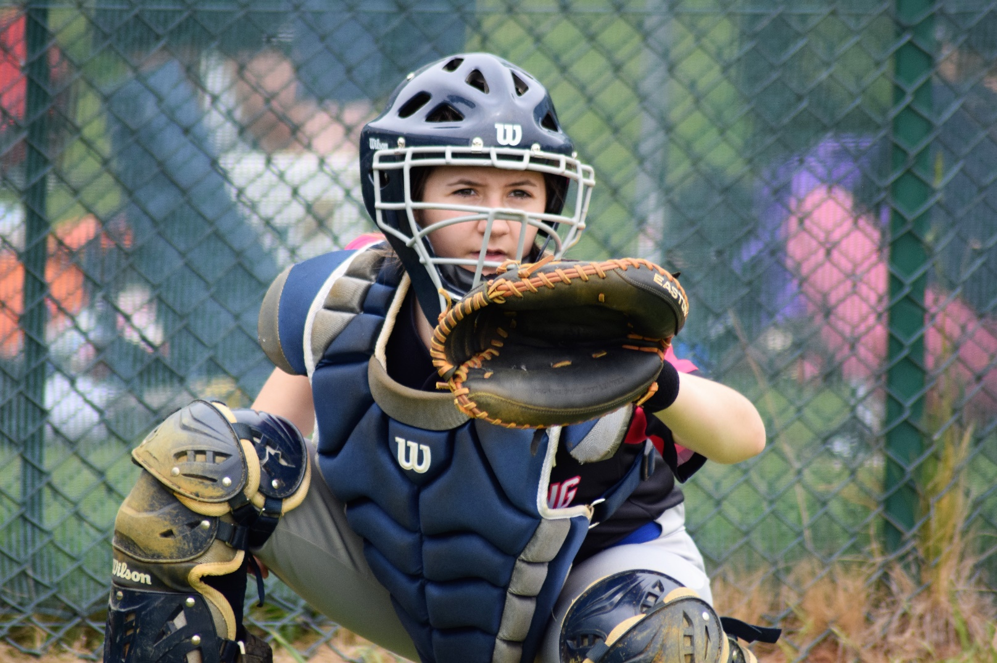

Criminal Records Check

(DBS) Policy

Diversity, Equality and Inclusion

Diversity, Equality and Inclusion (DEI&I) ensures fair treatment and opportunity for all. It aims to eradicate prejudice and discrimination on the basis of an individual or group of individuals’ protected characteristics.

BaseballSoftball UK takes seriously its role in recognising and removing any barriers faced by people involved or wanting to be involved in our sports, in any capacity, to ensure the culture of our sports are improved to one that values diversity and enables the full involvement of disadvantaged groups in every aspect of our sports.

Please see the Equality, diversity and Inclusion (EDI) Policy for further detail

CRIMINAL RECORD CHECK (DBS) POLICY
As part of BSUK’s overall safeguarding strategy, criminal record checks are an essential factor in safe recruitment procedures for clubs.
It is a legal requirement for all individuals applying to work in 'Regulated Activity' to complete a criminal record check including a barred list check, in England, Wales and NI this is a Disclosure and Barring Service (DBS) check (Scotland use Disclosure Scotland). The check will identify any relevant criminal record and show whether an individual is barred from working with children.
The result of the criminal record check is applied for by the individual that will be employed or deployed (if a volunteer) in regulated activity within the club or baseball softball. The criminal record check certificate must then be sent to the Lead Safeguarding Officer at BSUK for review and to update the database held at BSUK.
Criminal record checks must be completed on a yearly basis.

The (original) criminal record check certificate must be sent to:
The Lead Safeguarding Officer
BaseballSoftballUK
Home Plate
Farnham Park Baseball & Softball Complex
Beaconsfield Road
Farnham Royal
SL2 3BP

Criminal record check forms (for the DBS check) are available on request from BSUK, and the check is free of charge for volunteers. Club Safeguarding/Welfare officers can administer the completion and checking of DBS forms for the club.

Club structures vary, so it’s best to check who in your club requires a DBS check.
ALL Clubs - the DBS system is in place to ensure that all its staff and volunteers who are in a role that involves working with children or adults at risk, otherwise known as ‘Regulated Activity’, are safe to do so.

For further information or support please contact welfare@bsuk.com
or
call 0207 453 7055.
Further information about DBS checks can be found on the Gov.uk website - https://www.gov.uk/government/organisations/disclosure-and-barring-service/about

Policy Last reviewed | Reviewed By (Consultant) | Approved by | Next review date
Feb 24 | Katherine Bates |  | Feb 26

