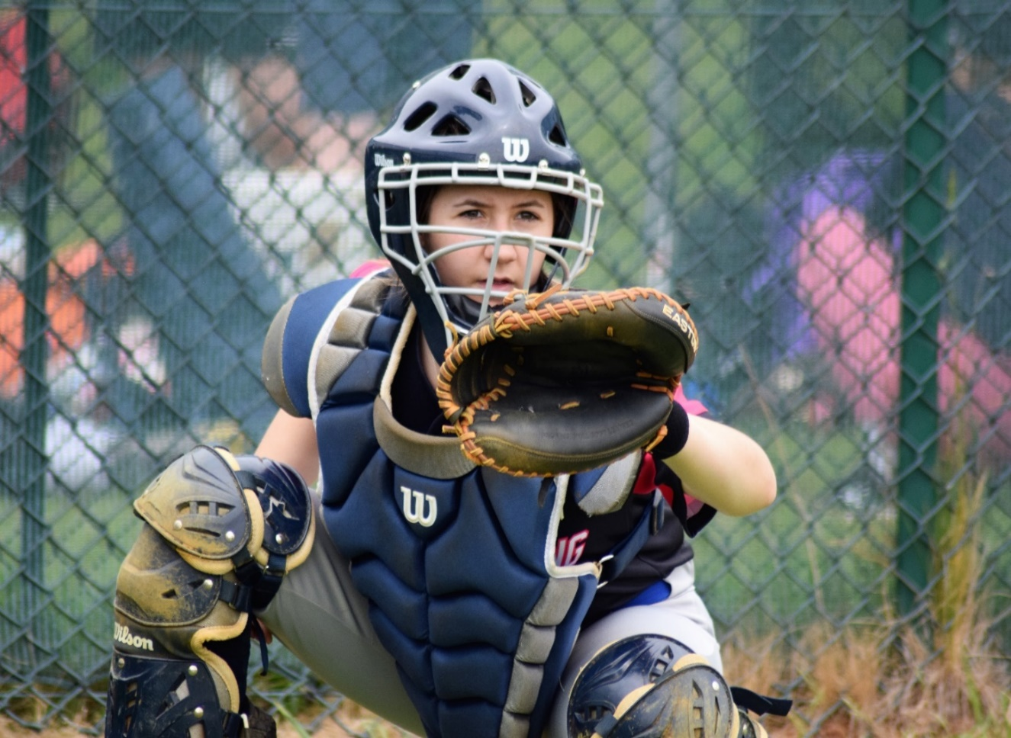

Anti-Bullying Policy for Baseball

and Softball

Equality, Diversity and Inclusion (EDI)

Equality, Diversity and Inclusion (EDI) ensures fair treatment and opportunity for all. It aims to eradicate prejudice and discrimination on the basis of an individual or group of individuals’ protected characteristics (please see the equality, diversity and inclusion (EDI) policy for further detail)

BaseballSoftballUK takes seriously its role in recognising and removing any barriers faced by people involved or wanting to be involved in our sports, in any capacity, to ensure the culture of our sports are improved to one that values diversity and enables the full involvement of disadvantaged groups in every aspect of our sports.
INTRODUCTION
Sport can and does have a powerful and positive influence on its participants, especially young people. Not only can it provide opportunities for enjoyment and achievement, it can also develop valuable qualities such as self-esteem, leadership and teamwork. These positive effects can only take place if sport is in the hands of those who place the welfare of all participants first and adopt practices that support, protect and empower them.
The reality however, is that abuse does take place in sport and in some cases coaches and other trusted adults in sport have been convicted of criminal offences and/or disciplined by their National Governing Body (NGB).
The British Softball Federation (BSF) and BaseballSoftballUK (BSUK) are committed to working together and in partnership with all relevant agencies to ensure that we fulfil our legal and moral obligations to safeguard and promote the welfare of all participants, and specifically young people.
This Anti-Bullying Policy is mandatory for all BSF and BSUK officials, staff and members, and for members of all affiliated organisations when engaged in baseball and softball activities with young people. You are expected to adopt, implement, actively promote and display all aspects of this Anti-Bullying Policy.

The club or organisation will:

- Help to create a culture that encourages all children to speak out against bullying and share any concerns they may have.
- Commit to providing a friendly and safer environment for our members to participate and enjoy.
- Recognise its duty of care and responsibility to safeguard all participants from harm.
- Promote, implement and display this Anti-Bullying Policy in addition to our Safeguarding Policy and Procedures.
- Seek to ensure that bullying behaviour is not accepted or condoned.
- Require all members of the club/organisation to be given information about, and sign up to, this Policy.
- Take action to investigate and respond to any alleged incidents of bullying.
- Encourage and facilitate children and young people to play an active part in developing and adopting a code of conduct to address bullying.
- Ensure that coaches are given access to information, guidance and/or training on bullying.

Each participant, coach, volunteer or official will:

- Respect every child’s need for, and right to, a play environment where safety, security, praise, recognition and opportunity for taking responsibility are available.
- Respect the feelings and views of others.
- Recognise that everyone is important and that our differences make each of us unique and that we should be valued.
- Show appreciation of others by acknowledging individual qualities, contributions and progress.
- Be committed to the early identification of bullying, and prompt and collective action to deal with it.
- Ensure safety by having rules and practices carefully explained and displayed for all to see.
- Report any incidents of bullying they see. By doing nothing you are condoning bullying.

Bullying

- All forms of bullying will be addressed.
- The responsibility to remove bullying from the club/organisation is everyone’s responsibility.
- Bullying can include online (cyber bullying) as well as off-line behaviour.
- Types of bullying can include:
  - PHYSICAL - pushing, kicking, hitting, slapping, pinching etc.
  - VERBAL - name-calling, sarcasm, spreading rumours, persistent teasing and emotional torment through ridicule, humiliation or the continual ignoring of individuals, gossiping.
  - CYBER - posting derogatory or abusive comments, videos images on social network sites.
  - SEXUAL - sexual comments, suggestions or behaviour and inappropriate physical contact.
  - OTHERS - racial taunts, graffiti, gestures or sectarianism.

- Bullying is often aimed at certain people because of their race, religion, gender or sexual orientation and can be other characteristics such as their appearance, disability and their beliefs.

Support to the child.

- Children should know they will be listened to and supported.
- Systems should be established to ensure any child can talk about bullying or any other issue that affects them.
- Potential barriers to talking (including those associated with a child’s disability or impairment) need to be identified and addressed at the outset to enable children to approach adults for help.
- Children should have access to Helpline numbers (eg Childline 0800 1111).
- Anyone who reports an incident of bullying should be listened to carefully and be supported.
- Any reported incident of bullying should be investigated objectively, including listening carefully to all those involved.
- Children being bullied should be supported to play and live in a safe environment which allows their healthy development.
- Those who bully should be supported and encouraged to stop bullying.
- Sanctions for those bullying others that involve long periods of isolation, or which diminish and make individuals look or feel foolish in front of others, are not acceptable.

Support to parents/guardians.

- Parents/guardians should be provided with a copy of the club/organisation’s bullying policy and practice.
- Any incident of bullying will be discussed with the child’s parent(s)/guardians.
- Parents will be consulted on action to be taken (for both victim and bully) and agreements made as to what that action should be.
- Information and advice on coping with bullying will be made available.
- Support should be offered to parent(s), including information on other agencies or support lines.

Action to help the victim and prevent bullying in sport.
- Take all signs of bullying very seriously.
- Encourage all children to speak and share their concerns (it is believed that over 200 children die by suicide each year as a result of bullying (Papyrus), so if anyone talks about or threatens suicide, seek professional help immediately). Help victims to speak out and tell the person in charge or someone in authority. Create an open environment.
- Investigate all allegations and take action to ensure the victim is safe. Speak with the victim and the bully(ies) separately.
- Reassure the victim that you can be trusted and will help them, although you cannot promise to keep what has happened a secret.
- Keep records of what is said (what happened, by whom, when, where and if possible, why).
- Report any concerns to the Club Safeguarding Officer or the Designated Safeguarding Lead (DSL) at their School (wherever the bullying is occurring).

Action towards the bully(ies)
- Talk with the bully(ies), explain the situation, and try to get the bully(ies) to understand the consequences of their behaviour. Seek an apology to the victim(s).
- Inform the bully(ies)’s parents.
- Provide support for the victim's coach.
- Impose sanctions as necessary.
- Encourage and support the bully(ies) to change behaviour.
- Hold meetings with the families concerned to report on progress.
- Inform relevant members of the organisation of the action taken.
- Keep a written record of action taken.
- Review any learning from having to respond to bullying behaviour.
- Most 'low level' incidents will be dealt with at the time by coaches and volunteers. However, if the bullying is severe (e.g. a serious assault), or if it persists despite efforts to deal with it, incidents should be referred to the designated Club Safeguarding Officer as in ‘Responding to suspicions or allegations’ below.

Responding to allegations or suspicions
It is not the responsibility of anyone working in baseball or softball to decide whether bullying or child abuse has or is taking place. However, there is a responsibility to act on any concerns by reporting these to the appropriate officer or the appropriate authorities.

The BSF and BSUK will assure all staff/volunteers that it will fully support and protect anyone who in good faith reports a concern they may have about a child or an adult’s behavior towards a child.

Adopted by Committee.
Club Name
Club Welfare Officer
Date

Policy Last reviewed | Reviewed By (Consultant) | Approved by | Next review date
Feb 24 | Katherine Bates |  | Feb 26

